Project Design Phase-II
Data Flow Diagram & User Stories
Date | 18 june 2026
Team ID
Project Name | HOUSE RENT
Maximum Marks | 4 Marks

Data Flow Diagrams:
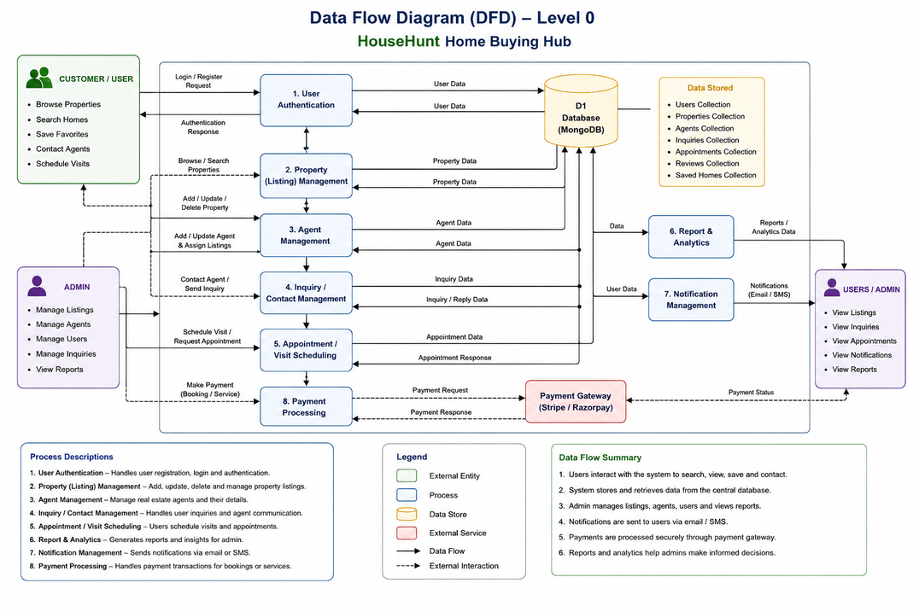

User Stories – House Hunt
User Type | Functional Requirement (Epic) | User Story Number | User Story / Task | Acceptance Criteria | Priority | Release
Customer (Web User) | Registration | USN-1 | As a user, I can register using name, email, password, and role. | User account is created successfully and stored in the database. | High | Sprint-1
Customer (Web User) | Login | USN-2 | As a user, I can log in using valid credentials. | User is authenticated and redirected to the homepage. | High | Sprint-1
Customer (Web User) | Authentication | USN-3 | As a user, I can securely access my account after login. | User session is maintained securely. | High | Sprint-1
Customer (Web User) | Property Catalog | USN-4 | As a user, I can browse all available property listings. | Property listings are displayed successfully. | High | Sprint-2
Customer (Web User) | Property Search | USN-5 | As a user, I can search properties using keywords or location. | Matching properties are displayed. | High | Sprint-2
Customer (Web User) | Property Filtering | USN-6 | As a user, I can filter properties by price, type, and location. | Properties are filtered correctly. | Medium | Sprint-2
Customer (Web User) | Favorites Management | USN-7 | As a user, I can save properties to my favorites list. | Selected properties are added to favorites. | High | Sprint-3
Customer (Web User) | Favorites Management | USN-8 | As a user, I can remove properties from my favorites list. | Property is removed successfully. | High | Sprint-3
Customer (Web User) | Property Inquiry | USN-9 | As a user, I can send inquiries regarding a property. | Inquiry is submitted and stored successfully. | High | Sprint-3
Customer (Web User) | Inquiry History | USN-10 | As a user, I can view my previous property inquiries. | Inquiry history is displayed correctly. | Medium | Sprint-4
Administrator | Admin Dashboard | USN-11 | As an admin, I can access the admin dashboard. | Admin dashboard loads successfully. | High | Sprint-4
Administrator | Property Management | USN-12 | As an admin, I can add new property listings. | Property is added and visible in the listings. | High | Sprint-4
Administrator | Property Management | USN-13 | As an admin, I can update property details. | Property information is updated successfully. | High | Sprint-5
Administrator | Property Management | USN-14 | As an admin, I can delete property listings. | Property is removed from the database. | High | Sprint-5
Administrator | User Management | USN-15 | As an admin, I can manage registered users. | User details are displayed and managed successfully. | Medium | Sprint-5
Administrator | Inquiry Management | USN-16 | As an admin, I can view and manage user inquiries. | Inquiries are displayed and managed successfully. | High | Sprint-5

